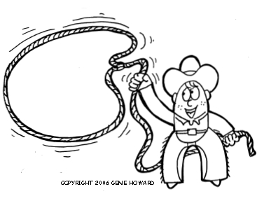
Western Week
School Wide
Dress Up Day Friday
May 22-25, 2018
Noon Hour Events:
Tuesday: Square Dancing g
Wednesday: Washer Toss & Pie Eating Contest
Thursday: Show & Shine & Outdoor Concert
Friday: Farmers Olympics & Cow Patty BINGO

