Name_________________________________ Music 9 – Test 2 Theory Review
Scale Writing: 3pts/question
Write a major scale with accidentals (sharps and flats) beginning and ending on the following notes

1. Eb – Major Scale

2. E – Major Scale

3. Ab – Major Scale
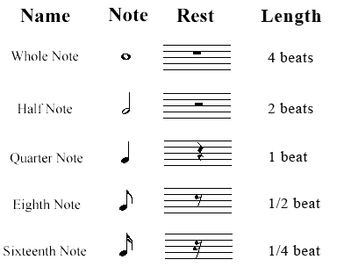
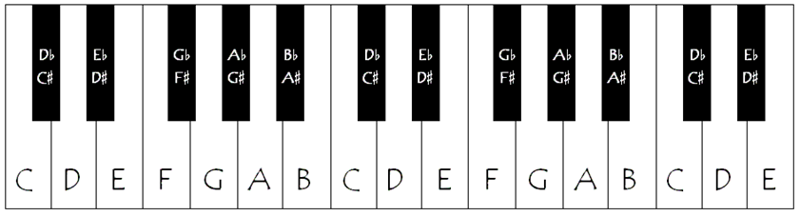

Draw the Bar Lines: 3pts/question
Based on the time signature, divide these pieces of music into measures
