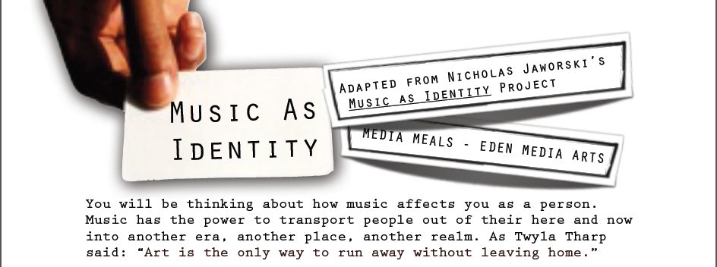
MUSIC AS IDENTITY PROJECT
Create a 2-4 minute podcast about you and the kind of music you like - how you think you are identified by your choices of music tastes. Include 6 songs that you feel outline your music identity. They can be very similar or very different.
This project consists of:
-reflection: What is music’s role in your life?
-gathering: What songs will you choose to
-writing: What is your script? How will the listener gain a better understanding of you?
-recording: Using recording software such as Garageband or Audacity to assemble your project.

STEPS
1
You will write a few paragraphs on the music that is important in your life. Make sure to talk about the music that helps shape your identity. You might also want to discuss the music that you secretly love, but other people don’t know about. You might want to start listing favorite artists, songs, or genres. The important thing here is to focus on the music that relates to you and helps define you in some way. Why do you love it? What does that say about you? What do you hope it says about you?
2

Find 6 songs. Songs from your childhood, songs you just started listening to, songs that mean something to you, songs that you “just love” Bring in the CDs. Rip them at home to a USB Flash drive. Ask for help with getting them to school.

You have your collection of 6 songs. Now you have to determine what those songs represent to you and/or what you hope they say about you. Write about each song. Here are some suggestions to get you started:
3
1) When did you first hear this song?
2) What does this song represent to you?
3) Is there a specific part of the music that is most significant?
4) Is this a piece of music that you share with your friends or family?
5) Is this a “guilty pleasure” song? (A song that you don’t want other people to know about).
4
Write your script and record it. Using Garageband or Audacity, record your voice by reading through your script. Be sure to leave some space between your sections (between each song). Import the songs in the program.
Tips

BE SURE to adjust the song volume’s accordingly. You do not want the voice to be overtaken by the songs in the background. ADD SOME transitions - cross-fading - between songs. Play with the volume levels between your “paragraphs”. If you pause or add a pause, bring the music volume up slightly and dip it back down when you begin talking again.

REFLECTION
5
Be sure to fully answer the questions in paragraph form (~3 paragraphs)
1) Do you feel any differently about music’s role in helping to shape your identity? Why or why not?
2) Do you see a connection between music and identity? Why or Why not?
3) Do you believe that people choose the music they listen to? Why or why not?
4) Do you feel like the music you listen to accurately reflect the person you want to be? Why or why not?
5) Do you feel comfortable with using Garageband/Audacity to create sound projects? Does it give you an appreciation for how musicians and producers create the music you listen to?

A FEW MORE POINTERS...
If you own a Flash drive, keep it with you every day, just save your updated work to your Flash drive.
If you don’t own a Flash drive, sign up for a free Dropbox.com account. Ask for help setting it up and you can upload your progress to your Dropbox.

