2B_Text Image Unit 2 – Typography

2B_Your own design

2C_Text in image

2C_Your own design

2D_Text Path

Website Banner

3A_Fontraham_lincoln Unit 3 – Image Manipulation

3A_Your own design

3B_Double Exposure

3B_Your own design

3C_Duotone

3C_Your own design

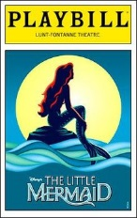

Design Challenge 2 _ The Little Mermaid

3D_SkullFace

3D_your own design

Design Challenge 3 _ Rick Mercer Photo Challenge

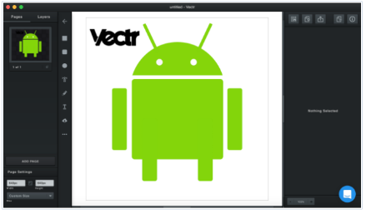
4B_ Vectr Basics/Android Unit 4 – Vectors

Design Challenge 4A_ Logo/School Lobby Project

4D – Inkscape Basics/Letter Logo

4D – Your own design

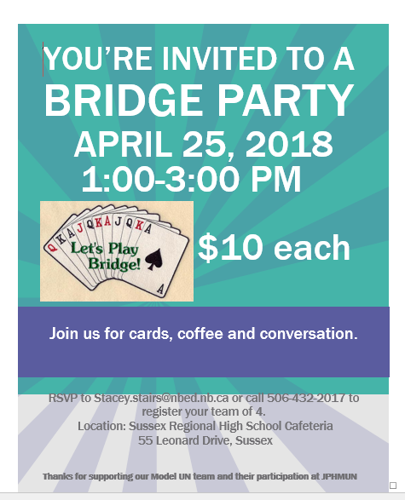
Design Challenge 4B – Grad Class Posters
Complete a poster design for any of the following events
- 5A_Fashion Show
- 5B_Bridge Party
- 5C_Sitandpaint
all info and materials are located in Mr. MacEachern's
teacher public folder/S.Stairs Poster
Design and judging will take place before April 5

4F – Raster to Vector
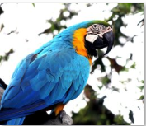

Design Challenge 4C - Sit and Paint/Sawyer Stanley/Safe Grad shirt
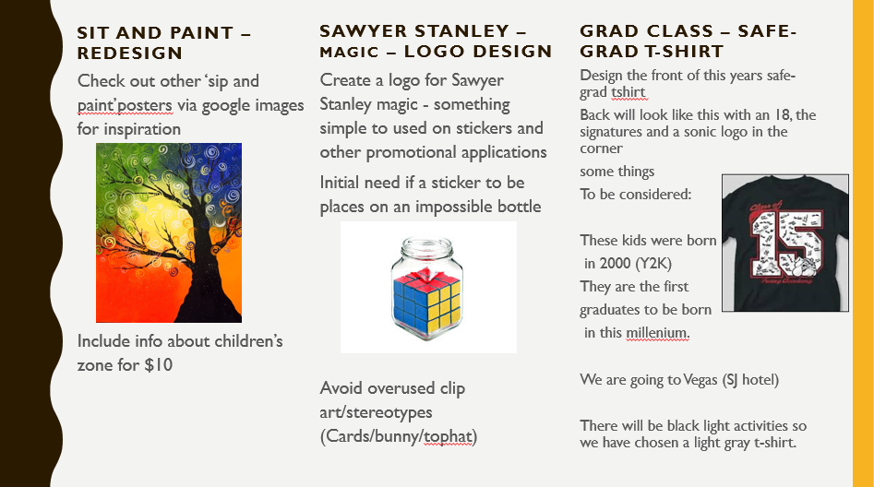
Complete a poster design for any of the following events

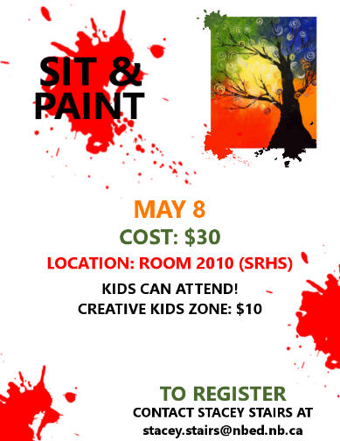
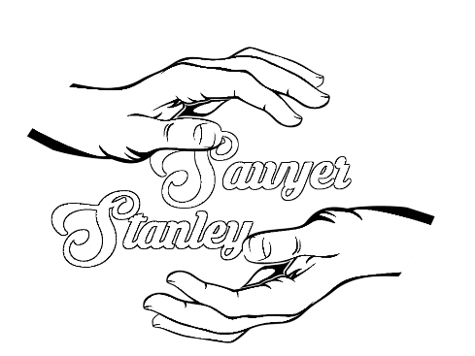

5A – Retro Text (Gimp)

Design Challenge 5 – SYS/Valley Jamboree/Tech Door

5B Vector Cow
5C Vector Lego

Exam Portfolio Projects
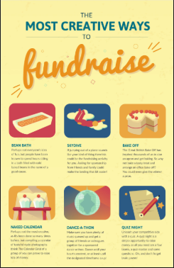
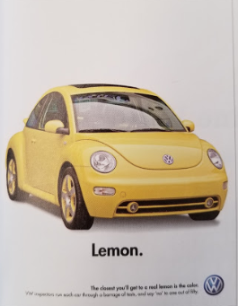
EPP1 Collage EPP2 Retro EPP3 Info Graphic EPP4 Slogan

