Mesopotamia
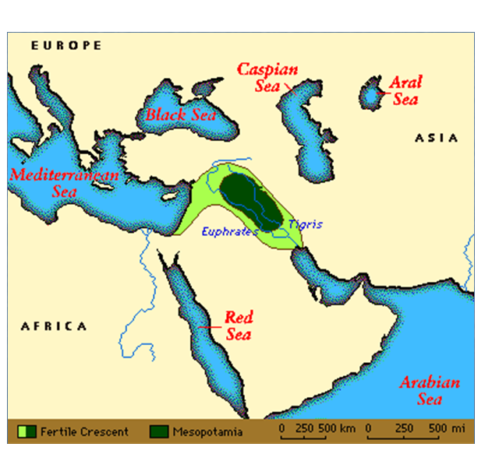
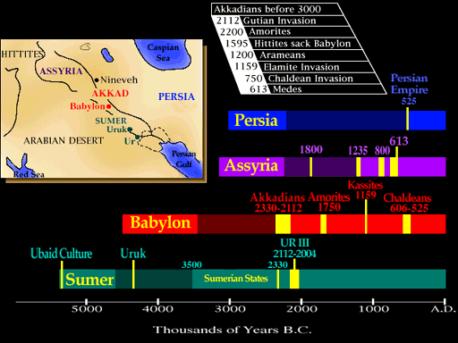

Sumer
Early Pioneers: One day, a group of early settlers wandered into the land between the Tigris and Euphrates rivers. No one knows for sure, but there may have been a small band of people already living in the area. If so, the settlers quickly took over. They were real pioneers. They built permanent homes of sun-dried bricks made of mud and straw, and started a new life in the southern region of ancient Mesopotamia.
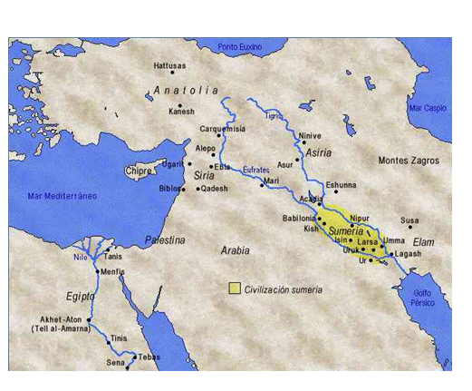
The people who settled down and began to develop a civilization, in the land between two rivers, are known as the Sumerians. About a thousand years later, the Babylonians took over in the south, and the Assyrians took over in the north, but the Sumerian culture lived on.
The Sumerian civilization probably began around 5000 BCE. In the beginning, they were an agricultural community. They grew crops and stored food for times of need. It did not rain much, but the early settlers soon learned that if you irrigated the land, crops grew quickly. These early people built canals to bring water to the land from the rivers. They planted wheat, barley, dates, and vegetables including cucumbers, onions, apples, and spices.
They raised sheep, goats, and cows. They hunted wild game birds and other animals, and enjoyed fish, cheese, eggs, roasted duck, pork, and deer.
Religion and Ziggurats: The Sumerians believed that many, many powerful gods lived in the sky. They believed that everything that happened to them - be it good or bad - was the result of a god's pleasure or displeasure.
Much of their daily life was spent seeking ways to please and appease their gods. In spite of all their efforts, many of their gods remained gloomy anyway.
Ziggurats were temples. They built huge structures, called ziggurats, with steps climbing up to the top. Religious ceremonies were held at the very top. People left offerings of food and wine. The priests enjoyed these offerings, as the gods could not eat for themselves.
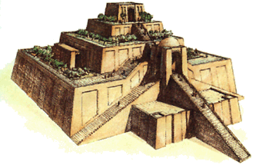
The Ziggurat was built in the center of town. It was also the center of daily life. Except for festivals, which, for the most part, were gloomy things, the Ziggurat courtyard was gay and lively. You might see an artist painting, a boy racing by on his way to school, someone milking a cow or making a basket.
From the top of the Ziggurat, you could see the protective wall built about the entire town, and over the wall to the farmlands beyond.
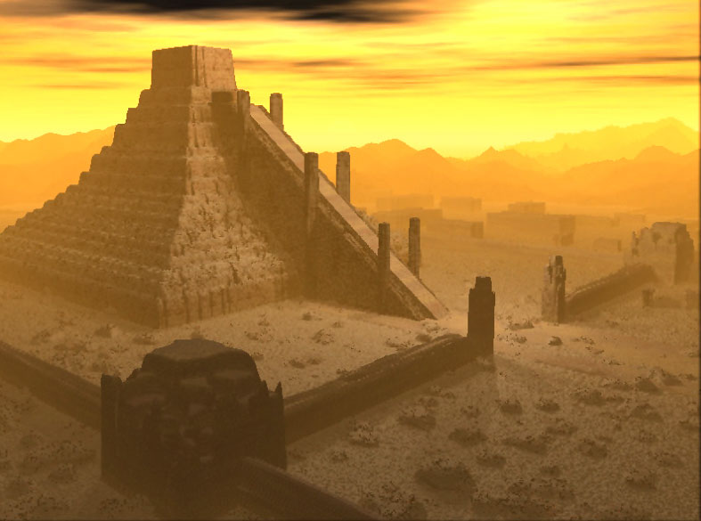
Early Inventions: The ancient Sumerians were very smart. They invented, amongst other things, the wheel, the sailboat, and the first written language, frying pans, razors, cosmetic sets, shepherd’s pipes, harps, kilns to cook bricks and pottery, bronze hand tools like hammers and axes, the plow, the plow seeder, and the first superhero, Gilgamesh.
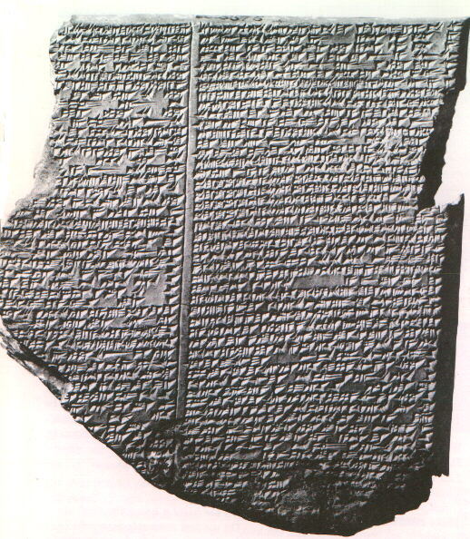
Cuneiform: Their written language began as pictographs, pictures of things that acted as words. Pictographs worked, but they were rather cumbersome. Soon, the clever ancient Sumerians started to use wedge-shaped symbols for objects and ideas instead of pictures. Today, we call this written language of wedge-shaped symbols cuneiform.
We know a great deal about the ancient Sumerian civilization from the written records they left behind in stone and clay. The ancient Sumerians kept excellent records and lists of things. They listed their household goods. They listed their court activity. They listed their sales and purchases. They even kept a list of their kings that was updated from time to time, as new kings came to power.
One of the best things the ancient Sumerians wrote down was a great story called The Epic of Gilgamesh. The Epic of Gilgamesh is perhaps the oldest recorded story in the world. It tells about the adventures of a king of Uruk, one of the city-states in ancient Sumer. King Gilgamesh may actually have existed. His name is on the list of Sumerian kings, a list we know about because the ancient Sumerians wrote it down.
Cuneiform became the written language from as early as 5000 BCE. As the civilization of Sumer started to decline, other civilizations continued to use the Sumerian written symbols. Thanks to the Sumerians, we also know a great deal about the ancient Mesopotamian civilizations of Babylon and of Assyria, civilizations who used the ancient Sumerian system of writing - cuneiform.
Although cuneiform was used for many thousands of years, and many things have been discovered written in cuneiform, cuneiform is still not easy to read. That is because the shape of cuneiform letters, and the meanings of various cuneiform symbols, changed over time and varied by region. When archaeologists find ancient cuneiform script, they are always excited about it. But, they need time to translate it to discover if they have found a household list of repaired items, or a new poem or story. There is much yet to be discovered about these ancient people as archaeologists continue to translate the ancient written language of Cuneiform.
They invented a system of mathematics based on the number 60. Today, we divide an hour into 60 minutes, and a minute into 60 seconds. That comes from the ancient Mesopotamians.
Some Mesopotamian words are still in use today. Words like crocus, which is a flower, and saffron, which is a spice, are words borrowed from the ancient Mesopotamians.
Education: The ancient Sumerians believed in education. Record keeping was very important to them. They wanted their sons to learn how to read and write. Schools were attached to temples. Only boys went to school.
Teachers were very strict. Students had to do a perfect job, or they were punished (usually whipped.) In spite of the punishment they quite often received, most students wanted to go to school anyway. Someone who could read and write could always find a good job.
Government: The ancient Mesopotamians created a government that was a combination of monarchy and democracy. Kings ruled the people. Elected officials who served in the Assembly also ruled the people. Even kings had to ask the Assembly for permission to do certain things.
Law and Order: Law held a special place in their civilization. In Babylonian times, laws were actually written down. But there were always laws. The laws clearly said how you had to behave and what your punishment would be if you did not behave correctly. And the laws that were later written down, for the most part, were laws created by the ancient Sumerians.
Cities: The ancient Sumerians built many cities along the Tigris and the Euphrates Rivers. Archaeologists believe that their largest city, the city of Ur, had a population of around 24,000 residents!

Babylonia
About a thousand years after the ancient Sumerians settled in the land between two rivers, two new civilizations arose. One was the warrior civilization of the Assyrians in northern Mesopotamia. The other was the ancient civilization of Babylonia. Babylonia was located in southern Mesopotamia, near the Persian Gulf.
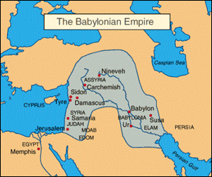

Law: Hammurabi was an ancient Babylonian king. He did something that no one had ever done before. The Sumerians had created the first written language, cuneiform. Using this written language, Hammurabi created the first written set of laws.

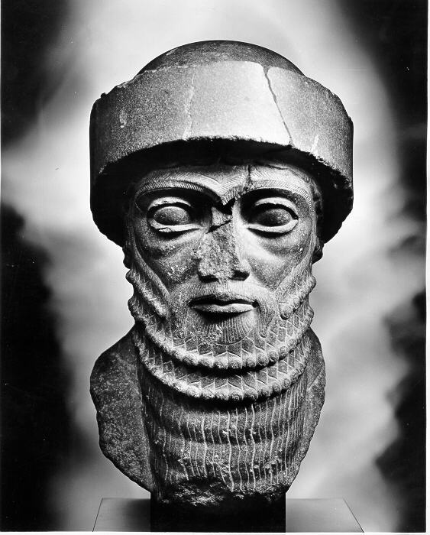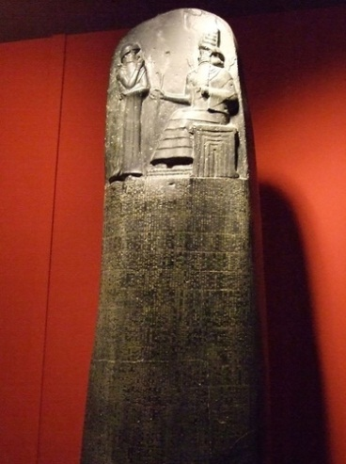
In Hammurabi's court, it did not matter if you were rich or poor. If you broke the law, and were found guilty, you would be punished.
Since the laws were clearly written down, everyone was expected to obey them.
Religion: The ancient Sumerians worshipped Marduk. To them, he was an important god. But, to the ancient Babylonians, Marduk was the most important god of all. When King Hammurabi declared Babylon to be the capital of Babylonia, he built the city of Babylon in Marduk's honor.
Living in Babylon: 3500 years ago, Babylon was an impressive place. It was a massive walled city, with a network of canals and vivid green crops. Even from a distance, visitors could see the top of the 300-foot high Ziggurat long before they reached the huge city gates.
One of the most impressive sites was Procession Avenue, the street that led into the city. Huge brick animals were positioned along both sides of the avenue. The avenue passed under the Ishtar Gates, the elaborate gate to the walled city. The gates were designed with dragons and bulls in honor of the god Marduk.
Once inside the walls that protected the ancient city of Babylon, visitors and traders found many wondrous things to buy, like fresh fruits and vegetables, baked breads and cheese, warm coats, gold jewelry, and date wine.
Inside the wall, life teemed. There was no suburban or country living in ancient Babylon. The people had homes inside the walls of the city. The rich lived in large homes, and the poor lived in small homes. Most homes were clustered around the Ziggurat and each other. Most houses shared walls, like townhouses do today.
There was little wood and stone available for building materials. People built their homes of sun-dried brick. Doors led into a small family courtyard. The courtyard, or first floor, in each house was very important. Behind the front door, a visitor might find a tiny garden and domesticated animals such as chickens. Kids played in the courtyard.
Most homes were designed with three stories of living space. The first living space was the courtyard. Stairs led up to the second and third floors, and then to the roof.
Roofs were flat. Roofs provided a fourth living space. People cooked and slept on their roofs, when weather permitted. Some of the fancier roofs were designed with four walls for privacy. Some had grape arbors that provided food, privacy, and shelter from the sun.
As the cities grew, there were rich sections of town and poorer sections of town, but all families had a home of their own.
Once you reached your home, it was spacious and comfortable. But sometimes, it was hard to get home. Inside the wall, the streets were narrow and unpaved. Streets or alleys provided access to everyone's front door. People threw their trash out their front door. Now and then, the city covered the streets with a new layer of clay. This buried the trash, but made the level of the street higher. To get inside their homes, people had to build steps down to their front door, or fill in the space between the new street and the house, and then punch in a new door.
Assyria
Warriors: The Assyrians also lived in the land between two rivers. Their home was in northern Mesopotamia towards the mountains. They were famous traders. Their donkeys and caravans were known throughout the Mesopotamian area. Their religion was similar to that of Sumer and Babylonia. They worshiped many of the same gods. But they had their own language and their own lifestyle.
The Assyrians were always at war with somebody. Their warriors were fierce, and soon conquered many other people. They tried to conquer the southern regions of Mesopotamia, with an eye especially on controlling Babylonia, but their revolts were put down. They were much more successful attacking and conquering the people to the east and west.
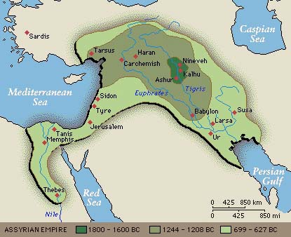
Assyrian artists were very talented. We know a great deal about life in ancient Assyria because of the wonderful legacy of art discovered by archaeologists. Talented artisans used art to tell stories of battles and war heroes with scenes painted on ceramics. There are scenes of warrior camps, men striding in armor, and war chariots, and baked bread. Bread must have been very important to these ancient people.
Religion: Not everyone lived in war camps. The Assyrians also built towns. In each town, they built huge buildings. Each building was decorated with huge demons to protect the building and the town from evil influences.
Archaeologists have discovered artifacts that suggest the ancient Assyrians believed in an afterlife. The ancient Assyrians buried their dead with a few of their favorite possessions, like weapons, drinking cups, and other small personal items. The poor would dig a hole somewhere and bury their dead at home. The rich would build a room just for the burial. In both cases, an oil lamp was kept burning near or at the gravesite, perhaps to light the way between worlds, or perhaps in honor of the deceased.
The Assyrians Conquer Babylon! Around 1200 BCE, the Assyrians finally conquered Babylon. Babylon was the greatest city of the age. Rather than take over the city for their own use, the Assyrians leveled it. They hated the Babylonians. Before they destroyed the town, they forced all the people to move to various places in Assyria. That's what the Assyrians always did when they conquered a new people. They moved them around, different people in different places, so the conquered people would find it difficult to revolt.
After they leveled the city, the Assyrians began to worry. What if Marduk, the great god, thought they were attacking him? They worried and worried, and finally decided to rebuild the city, so that Marduk would not punish them for destroying a city built in his honor.
They really had no use for the city. They rebuilt Babylon, but left it an empty city. Eventually, people found the empty city and moved in. Babylon rose again.
The Library at Nineveh: Around 600 BCE, before the people of ancient Mesopotamia were conquered by the great Persian Empire, the last Assyrian king started a project. He began collecting a library of clay tablets of all the literature of Sumer, Babylon, and Assyria. No one knows how many tablets he actually collected, but when this library was discovered in modern times, over 30,000 tablets still remained in the great library at Nineveh, his capital city.
These tablets are our single most important source of knowledge about ancient Mesopotamia. The tablets include the Story of Gilgamesh, Hammurabi's Code, and many other important documents and stories created by these amazing people - the ancient Mesopotamians.
Chaldea
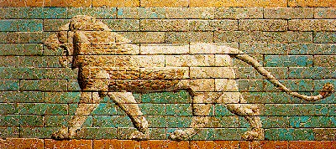
Following the destruction of Nineveh, Nabopolassar, who created the Chaldean dynasty and participated in the Mede and Babylonian invasion of Assyria, forced the Assyrians into north-western Mesopotamia. His son, Nebuchadnezzar (605-562 BC), assumed military control in Assyria and continued the removal of the Assyrians and their Egyptian supporters. Before Nebuchadnezzar could invade Egypt itself he learned that Nabopolassar had died, so he returned directly to Babylon, the Babylonian capital. There, he assumed the position of king. However, by 539 BC, Babylon had been conquered by Cyrus, ruler of Persia, and Mesopotamia was merged with the Persian Empire.
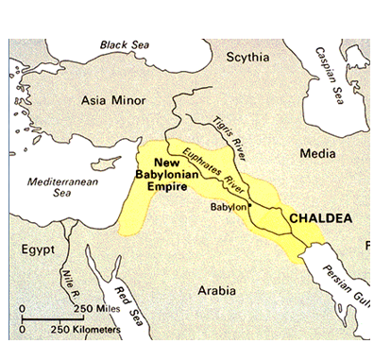
Nebuchadnezzar is perhaps best known for his elaborate Babylonian building projects. This king created the Hanging Gardens of Babylon, a terraced garden supposedly built to remind Nebuchadnezzar's wife of her mountainous homeland. The Ishtar Gate was another of Nebuchadnezzar's great accomplishments. It was located near the Hanging Gardens and decorated with reliefs of various creatures, including dragons and bulls.
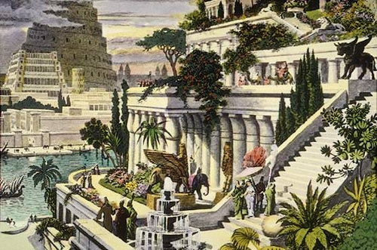
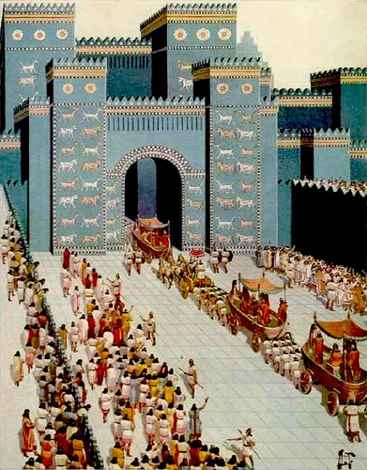
During the Chaldean period Nebuchadnezzar also worked to spur religious revival in Babylonia. The gods that ruled the universe were equated with one of the planets. Ishtar (goddess of life, fertility, sexual love, and war), for example, was equated with the planet Venus. Using their great skills in astronomy, the Chaldeans also used the movement and positions of the planets and stars to predict the plan of the gods and thus, the future. Astronomy was also utilized to create a method of time based upon a seven-day week, as well as days comprised of twelve 120-minute hours.
Persian Empire
During the hundreds of years before the birth of Christ, numerous Indo-European speaking tribes, known collectively as the Persians, were scattered throughout most of south-western Iran. Prior to 550 BC, the Persians were under the control of the Medes. In that year, the Persians, under the direction of their powerful leader Cyrus, conquered the Medes and took over all territory formerly under Median control. Three years later, Coesus, the king of Lydia, attacked the Persians but was defeated and his territory was confiscated. By 539, the Persians had also captured the land of the Chaldeans.
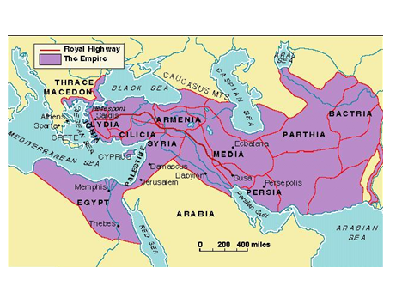
In 530, Cyrus died and was succeed by his son Cambyses (530-522). Cambyses expanded the borders of the Persian Empire to include Egypt. However, he took his own life in 522 due to stress induced by the threat of a revolt within the empire. It has also been suggested that Cambyses had been suffering from a mental illness which may have heightened his anxiety and led to his suicide. Cambyses' successor was Darius I (522-486), who seized control after a period of civil unrest.
One of Darius' greatest accomplishments was maintaining the unity of an empire that controlled so many different regions and groups of people. To govern such an area, Darius organized his empire into a series of provinces which were directed by individual governors, or satraps. These satraps collected taxes and soldiers for the king. Supervisors for the king, known as his "Eyes and Ears," traveled to each province to collect these items.
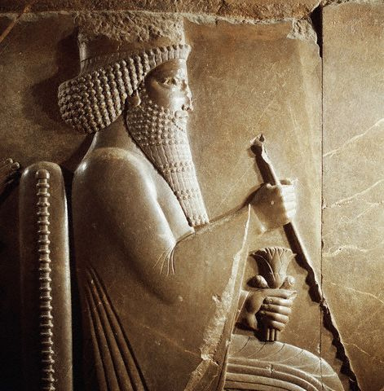
Darius also instituted a public works system within his massive empire. He organized a postal system, ordered the construction and improvement of roads, and order the casting of gold coins, known as darics. Darius also set up a standard system of weights and measures for the empire. He also began building palaces and other structures at the city of Persepolis, the royal center of his empire, in south-western Iran.
The accomplishments of Persia were great in the areas of conquering, unifying, and governing territories, but these achievements also extended to the area of religion. Zoroaster (628-551), a religious prophet, developed a religion which came to be accepted by many. In this religion, two gods, Ahura Mazda, god of light, truth, health, life, and goodness, and Ahriman, god of darkness and evil, were believed to exist together in a constant struggle for dominance in the universe. However, it was believed that Ahura Mazda would be the eventual victor, and on Judgment Day, all people who have ever lived -- both alive and dead -- would be sent to either heaven or hell.

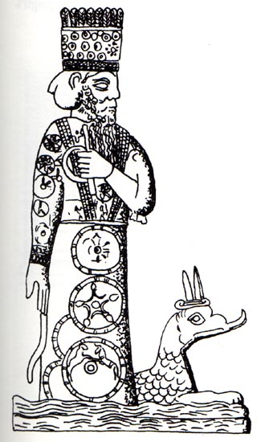
How Marduk Became King
of ALL the Ancient Babylonian Gods
The Problem: Once upon a time, a long time ago, the gods in the heavens wanted to rid themselves of the evil goddess Tiamat. Although every good god agreed that this was a great plan, no one wished to battle the evil goddess Tiamat, as she was very powerful.
The Good Guys: In desperation, Ea, the wise water god, decided that Marduk had the best chance of defeating the evil goddess. True, Marduk was young, but he had many powerful skills and was extremely quick witted. Ea asked Marduk if he would be willing to challenge the evil goddess Tiamat on behalf of all the Good Gods.
Marduk’s Terms: Marduk knew, if he took the job, he would have quite a fight on his hands. Marduk thought it over. He told Ea he would try to conquer evil if the good gods agreed to his terms. The good gods had to promise to reward Marduk with the permanent position of Chief of the Gods if he battled the evil goddess Tiamat and won.
Ea’s Tricky Plan: Ea knew he could not make such a deal on his own. Something of such importance would need the approval of the entire Assembly of the Gods. Ea was pretty sure that a lot of the gods would not be happy about this, especially the older ones who typically teamed up so their collective vote quite often ruled the day.
Ea decided to throw a banquet and invite the entire Assembly to the party. He really went all out to lull the gods into a peaceful and happy state. Ea had his servants serve mounds of pancakes, a most favorite and sought after food in ancient Mesopotamia. He ordered many huge vases, brimming with delicious date wine, be placed on the floor around the banquet table. Each god was given a tube (somewhat like a very long straw) to use to drink from the vases of wine. He had musicians play soft music on their pipes, accompanied by the bleating of live sheep, which was thought to be a most restful sound.
The combination of pancakes and date wine and the bleating of sheep put all the good gods in such a great mood that the entire Assembly agreed to Marduk’s terms. Besides, the gods really did not think the boy had a chance.
The Battle: Marduk armed himself with a bow and several arrows, a thunderous club, a net of storms, and a saw-toothed lightning dagger. He went in search of Tiamat.
Rolling his thunder and storms before him, Marduk fought one monster after another that the evil goddess Tiamat kept creating and throwing in his way. Each time he killed a monster, he moved closer to the evil goddess Tiamat. One day, he got close enough to catch her in his nets! Tiamat howled with fury. Before she could conjure yet another monster, Marduk shot an arrow down her howling throat, and killed her!
The mighty Marduk took his club and split Tiamat’s body in half. He placed half of her body in the sky and made the heavens. He posted guards to make sure she did not escape and gave them twinkling lights to show that all was well. He created the moon to guard the heavens, and set it moving back and forth, on endless patrol. With the other half of Tiamat's body he made the land. From each of her eyes, he set a river flowing. One eye made the Tigris River. The other eye watered the Euphrates River. He planted fields of grain and vegetables, and blessed the land with rain and cows and forests and orchards.
Why humans were first put on the earth: Marduk told the gods who had supported Tiamat that they had to work the fields and tend the canals as punishment. These gods soon complained of all the work they had to do. They burnt their spades and baskets in protest.
Marduk, with an eye on the future, offered the gods a deal. If they agreed to recognize Marduk for all time as the Chief of all the gods, he would release them and find others to do the work in their place. That’s how humans were first put upon the earth. Marduk created humans to do the work, to till and hoe, to tend the canals and animals, and to worship all the gods at festivals.
Chief of the Assembly of Gods: Impressed, and as promised, the gods awarded Marduk with the permanent position of first Chief, leader of the Assembly of all the Gods. To this day, Marduk’s symbol is the saw-toothed lightening dagger that he holds in his belt, his trusty weapon that still helps him keep order in the heavens.

